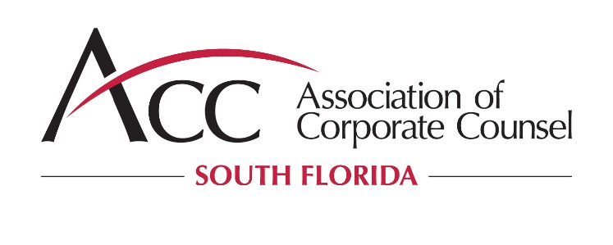

ACC South Florida Ambassador Program
2019 Scholarship Information

The South Florida Chapter of the Association of Corporate Counsel (ACC South Florida) will be selecting 8-10 law students for its 2019 Ambassador Program. Selected law students, or “ACC South Florida Ambassadors”: (1) receive a scholarship in the amount of $1,000.00; and (2) volunteer at various community service/pro bono events during the year. ACC South Florida Ambassadors will also be invited to attend and/or volunteer at select ACC South Florida events.

The Ambassador Program is a unique networking and educational opportunity that provides rare access to ACC South Florida’s in-house counsel membership and its sponsors.

About the Association of Corporate Counsel
The Association of Corporate Counsel is the world’s largest community of in-house counsel, serving the professional and business interests of attorneys who practice in the legal departments of corporations, associations, and other private-sector organizations around the globe.

ACC South Florida serves more than 575 members from the Palm Beach, Broward and Miami-Dade counties. ACC South Florida partners with its sponsors to provide innovative networking opportunities, substantive programs and community outreach by holding several diverse events for its members each year.

APPLICATION PROCESS
- Complete the scholarship application
- Submit your resume

ELIGIBILITY REQUIREMENTS
- ACC South Florida Ambassadors must be full or part-time students of accredited law schools located within the Broward, Miami-Dade, Palm Beach counties.
- ACC South Florida Ambassadors must maintain their part or full-time enrollment status throughout the academic year covered by the Ambassador Program.
- ACC South Florida Ambassadors must be a second year law student at the time of application.
- ACC South Florida Ambassadors may not be on any form of academic or civic probation, suspension, or judicial reprimand.

SELECTION CRITERIA
ACC South Florida Ambassadors will be evaluated and selected on the basis of their:

- Scholarship Application
- Telephone Interviews
- Recommendations of Law School

SCHOLARSHIP AMOUNT
The amount of the 2019 ACC South Florida Ambassador Program scholarship is $1,000.00.

PAYMENT OF SCHOLARSHIP FUNDS
ACC South Florida will pay scholarship amounts directly to the ACC South Florida Ambassador’s law school to be disbursed in two installments. The first installment of $500 will be paid at the beginning of the Ambassador Program. ACC South Florida Ambassadors must attend a minimum of three (3) community service/pro bono events, including the ACC South Florida annual CLE conference occurring in the Fall of 2019. If all of the Ambassador Program requirements are met, the second installment of $500 will be disbursed at the end of the Ambassador Program. ACC South Florida reserves the right to recover scholarship funds from selected ACC South Florida Ambassadors who do not make a good faith effort to complete the Ambassador Program.

IMPORTANT DATES*
Deadline to submit application: January 18, 2019
Telephone interviews conducted (as needed): The week of January 21, 2019
ACC South Florida ambassadors selected: January 31, 2019

LENGTH OF AMBASSADOR PROGRAM
February 2019 - December 2019

*Subject to change

2019 ACC SOUTH FLORIDA SCHOLARSHIP APPLICATION

Name:
Address:
Phone Number:
Email:
Law School:
Student ID (if applicable):
Year of Graduation:
GPA:
Legal Practice Area of Interest:

In 500 words or less, explain why you want to be an ACC South Florida Ambassador.

As an ACC South Florida Ambassador, you will be asked to attend a minimum of three (3) ACC South Florida community service/pro-bono events during the year. Please indicate any limitations you may have that may impact your ability to attend:

Please list any pro-bono or community service activities that you have participated in while attending law school.

If you have previously participated in the ACC South Florida Ambassador’s program, please provide the dates and details of your participation:

BY SIGNING BELOW, I AGREE THAT:

- I will participate in an interview with the ACC South Florida Community Service/Pro Bono Chair if requested.

- ACC South Florida may verify the information provided in my scholarship application with my law school.

- If selected as an ACC South Florida Ambassador, ACC South Florida may use my name, information regarding me, and my likeness in any news article or promotional stories.

Applicant Signature: _________________________________________________ Date:

Please submit the completed application and your resume to:

[each school will insert contact information / also post on website with ACC information].

DEADLINE FOR SUBMISSION IS JANUARY 18, 2019.

